Week 7(Object Oriented Programming)

Inheritance and Method Overiding

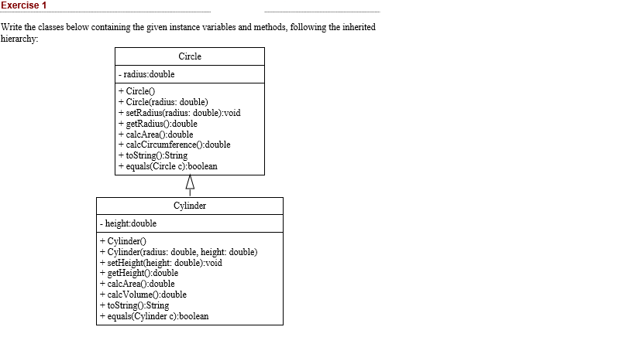

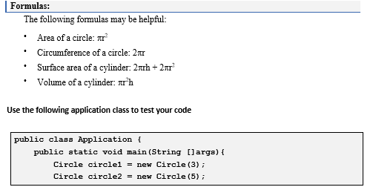

Question #2.

Apply the Concept of Composition by Creating part classes(doors,windows,Engine,Wheels) and than

Create a whole class Car that is composed of all these defined parts.

Question #3.

Create Box class containing data members (width ,height,Length) and Member functions showdata and Volume.. Apple the concept of Operator Overloading and overload operators (+,-,\* ,/) for addition subtraction multiplication and division of Objects of Box class.